Use Cases

These are the use cases we created for some generic uses of the JabRef tool.

Search Articles

Name | Search articles
ID | SEARCH_ARTICLES
Description | The user wants to search the web for articles on a topic.
Primary Actors | User
Secondary Actors | CCSB, MathSciNet, Crossref, Inspire, IEEEXplore, Springer, ACM, GVK, CiteSeerX, Medline, NASA ADS, DBLP, arXiv, JSTOR, DOAJ, Google Scholar, zbMATH Open
Pre-conditions | - The application must be running  - A library must be selected  - There must be an internet connection
Main Flow | 1. The use case begins when the user executes the Web Search action.  2. The use case ends when the article database replies with matching articles.
Post-conditions | The list of articles is presented to the user.

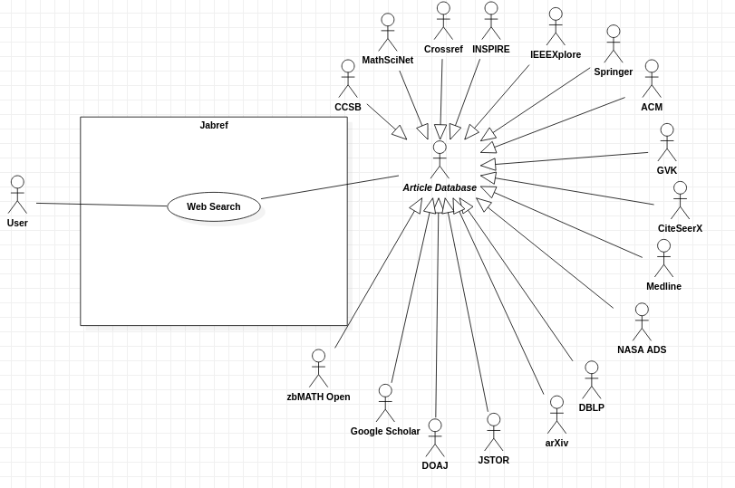
Create a Library

Name | Create a new library
ID | CREATE_LIB
Description | The user wants to create a new library to store entries.
Actors | User
Pre-conditions | There are no pre-conditions associated with this use case, besides the application to be running
Main Flow | 1. The use case begins when the user executes the new library action.  2. The use case ends when a new database is created
Post-conditions | The library is added to the jabref frame and the user can add entries to it.
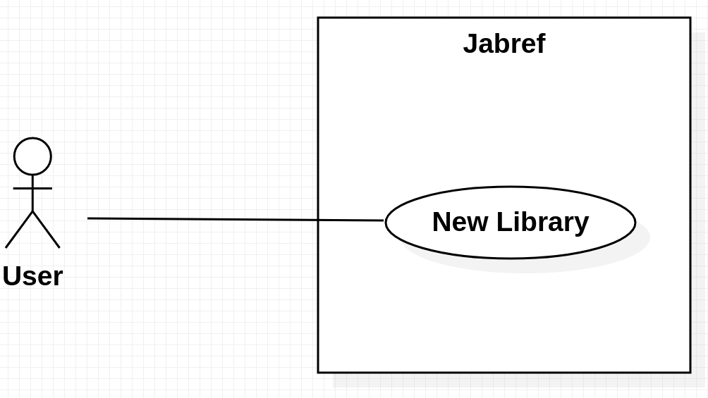

Insert an Article into a Library

Name | Insert an article into a library
ID | INSERT_ARTICLE
Description | The user wants to insert an article into a library.
Actors | User
Pre-conditions | The user must have selected a library.
Main Flow | 1. The use case begins when the user executes the new entry action.  2a. If the user wants to manually add an article, it goes to insert entry action.  2b. Use case ends when the user reaches the insert article action.  3. If the user wants to import a local file representing an article, it goes to import file to Library action and ends.  4. If the user wants to insert an article using text only, it goes to insert plain text action and ends.  5. If the user wants to import a file from the internet, it goes to import file from Web action then finishes when it reaches the web search action.
Post-conditions | The article has been created and inserted into the selected library.

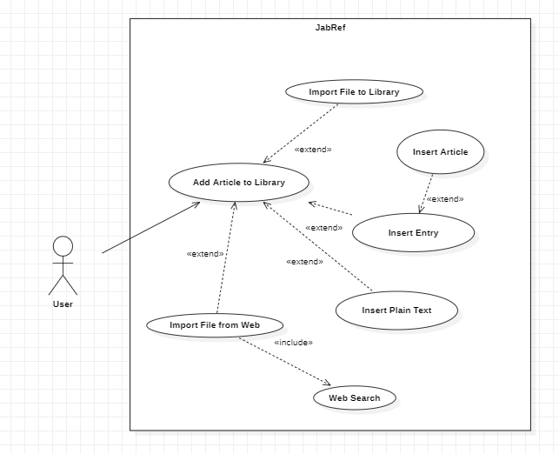

Remove an Article from a Library

Name | Remove an article from a library
ID | REMOVE_ARTICLE
Description | The user wants to remove an article from a library
Actors | User
Pre-conditions | User must have selected an article in a library.
Main Flow | 1. The use case begins when the user chooses an article from a library.  2. The user goes to Delete Entry action.  3. The use case ends when the user confirms the deletion of the selected entry or aborts the delete action and then finishes.
Post-conditions | The selected article has been removed from the library.
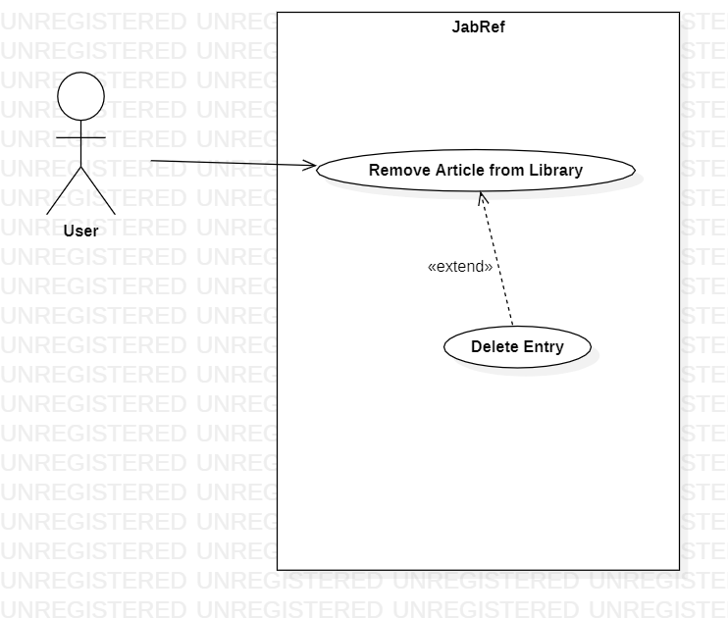

Export a Library to Tex

Name: | Export the library to Tex.
Id: | EXPORT_LIB_TO_TEX_0
Description: | The current user would want to export the current saved application file to LaTex file format.
Actors: | User
Pre-conditions: | - Created a file with atleast 1 entry or imported a file ready to export.
Main flow: | 1. The use case begins when the user creates a new application file or imports a existing one.  2. The user save the current file.  3. The system exports the application file located in a chosen path by the user.  4. The use case ends when the file is written.
Alternative flow: | None
Post-conditions: | A file with the result of the export was created in the path chosen by the user.
